

Travel By Bus

Project Proposal



Submitted To: Submitted By:

Sudeep Sir Pasang Sherpa

Module leader Batch 22C

**Contents**

**Chapter 1: Introduction** 2

**1.1** **Introduction** 2

**1.2** **Background of the project** 2

**1.3** **Problem statement** 2

**1.4** **Description of the project** 2

**1.4.1 Features of the project** 2

**1.5 Overview of the project** 3

**Chapter 2: Scope of the project** 3

**2.1 Scope** 3

**2.2 Limitation** 3

**2.3 Aim** 3

**2.4 Objectives** 3

**2.5 Overview of the scope** 3

**Chapter 3: Development methodology** 4

**3.1 Description of the methodology chosen** 4

**3.2 Design pattern** 4

**3.3 Architecture** 5

**Chapter 4: Project planning** 7

**4.1 Work Breakdown Structure** 7

**4.2 Milestone** 9

**4.3 Gantt chart** 9

**Chapter 5: Risk management** 12

**Chapter 6: Configuration management** 14

**Chapter 7: Conclusion** 14

**Chapter 8: Reference and Bibliography** 14

References 14

# **Chapter 1: Introduction**

## **Introduction**

Travel By Bus is the online bus ticket booking system. This is a web-based application where people can book ticket for bus seats for travel easily with less effort and time. This system is built for managing and computerizing the traditional database, ticket booking and travel made. It records and maintains all the customer details, bus details and booking (reservation) details. It also facilitates the online payment system.

## **Background of the project**

There are many website and applications like BusSewa.com, PNBBS, travelnepalbus.com, etc. especially for online ticket booking in Nepal. These websites provide such facilities in Nepal but most of the customers are still unfamiliar with them. There is also popular app called redBus which provide online ticket booking services but it is not available in Nepal. I got the concept of this project from redBus.

## **Problem statement**

At the present time, the system used in the bus ticket counter of Nepal is an internal system which is manually used in the selling the tickets. All the tasks are handled manually. All the customer details, bus details and booking details are recorded in register by the staffs. These records cannot be well-maintained manually and there may be difficulty while searching for the required past records. So, it takes more effort and takes more time in order to get required details. The main problem with the current system is customers have to go to the ticket counter and ask for the tickets which is very time-consuming. Sometimes, they have to queue up for long time and have to pay cash while buying tickets as they do not have any other options like online payment. So, it is very difficult for the customers as well as it requires more human resources to manage the current system.

## **Description of the project**

In order to solve the mentioned problems in the problem statement, the concept of this project was created. The main theme of this project is to develop a web-based application where people(customers) can book tickets for bus seats for travel without going to the ticket counter. After the completion of this project, ticket booking will be automated. It means it will consume less time and effort and less human resources will be used. Customers do not have to queue up for the bus tickets anymore after the completion of this project. They will also able to perform the online payment for booking. So, customers will not be bound to only pay cash for the booking the bus ticket. This project will also eliminate the traditional database. All the details on bus, customers, booking, etc. will be recorded and managed in computerized database. It will also facilitate while searching the required details. Required details can be obtained in less amount of time and effort.

### **1.4.1 Features of the project**

The main features of Bus ticket booking system are as follows:

* Online booking of ticket
* Online payment system for ticket

## **1.5 Overview of the project**

# **Chapter 2: Scope of the project**

## **2.1 Scope**

The scope of this system is people can book/reserve bus seats online. They don't have to go to ticket counter in order to buy tickets and can perform online payment instead of hand-to-hand cash payment. Booking can be done anytime, from anywhere. It will also computerize and manage the traditional database, ticket booking and travel made. It records and maintains all the customer details, bus details and booking (reservation) details.

## **2.2 Limitation**

The main limitation of this system is there might be problem while cancelling the reserved seats. This function will be only available to the company staffs. So, for cancelling the ticket, customers have to communicate with the staffs and talk with them. Currently, this project is mainly focused on developing web-based application. So, it means it will not be available as app for smartphones in Appstore (IOS) or Playstore (Android).

## **2.3 Aim**

The main aims of this project can be listed as below:

* To design the web-based application for booking the bus tickets.
* To design system which is user-friendly, time and effort saving.

## **2.4 Objectives**

There are so many objectives of the project in order to achieve its aims. Some of the main objectives to be fulfilled are as follows:

* Observation techniques is performed during analysis phase to get better view of what people want.
* Scheduling is done in order to finish project in time.
* To make it user-friendly, good and simple GUI is designed.
* Testing is performed to find out bugs in the system.
* Documentation of the project is done for the future reference.

## **2.5 Overview of the scope**

# **Chapter 3: Development methodology**

## **3.1 Description of the methodology chosen**

Among the many SDLC methodology, I have decided to use Waterfall model. Waterfall model is a linear, sequential and traditional approach to the software development life cycle. It consists of different stages and each stage are performed serially.

**Stages of the waterfall model**:

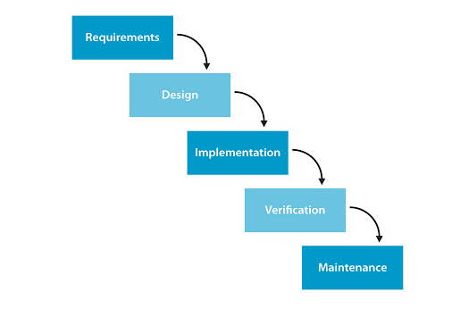

**Fig: Waterfall model**

I have chosen Waterfall model because of the following reasons:

* It is simple and easy to understand and use.
* Each stage is performed serially. So, no delay in development of the system.
* It facilities in scheduling.
* It is easy to arrange the tasks.
* Process and results are well documented.

## **3.2 Design pattern**

I will use MVC pattern for code architecture. It stands for "Model-View-Controller." It is a software architecture pattern, commonly used to implement user interfaces Below is a description of each aspect of MVC:

* **Model** - Model represents an object. It can also have logic to update controller if its data changes.
* **View** - View represents the visualization of the data that model contains.
* **Controller** - Controller acts on both model and view. It controls the data flow into model object and updates the view whenever data changes. It keeps view and model separate.

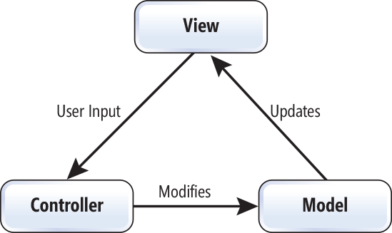

**Fig: MVC design pattern**

The reasons behind choosing MVC design pattern are as follows:

* Save time and effective use of resources.
* Rapid application development.
* Facilitates the multiple view.
* The modification never affects the entire model.

## **3.3 Architecture**

Software architecture is the high-level structure of system and the artifacts for creating such structures and systems. Among many of them, I will use client-server architecture for this project. In this architecture, Clients request services from the server and the server provides relevant services to those clients.

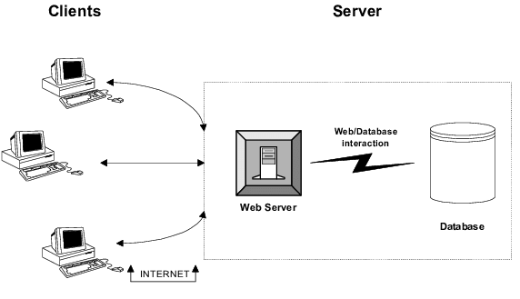

**Fig: Client-server architecture**

The advantages of using this architecture are as follows:

* All the data are stored in the central location.
* Users can access shared data which is centrally controlled.
* Backups and network security are controlled centrally.

# **Chapter 4: Project planning**

Project planning is the second and the most important phase in the project life cycle. It involves creating of a set of plans to help guide your team through the execution and closure phases of the project. The plans created during this phase will help us to manage time, cost, quality, change, risk and issues of the projects. It helps to ensure the project on time and within estimated budget. This phase is often the most challenging phase in the project life cycle.

## **4.1 Work Breakdown Structure**

Work Breakdown Structure is the process of dividing the complex project into simpler and manageable tasks. It also shows the interconnection between the various project tasks.

The benefits of using Work Breakdown Structure are as follows:

* Improve the accuracy of time, cost and resources
* Track progress in schedule
* Define the scope of the project
* Break the complex task into manageable chunks.

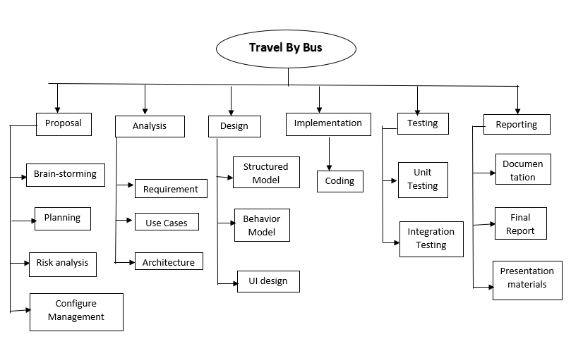

**Fig: Work Breakdown Structure (WBS)**

## 

## **4.2 Milestone**

Milestone is a project management tool that is used to delineate a point in a project schedule and shows an important achievement in it. We can obtain the following information about project with the help of milestone:

* The start date/point of significant project phases.
* The end date/point of significant project phases.
* The deadlines for something.
* When an important decision is being made. (Anon., n.d.)

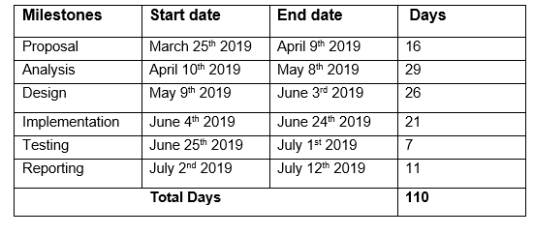

**Fig: Milestone of the project**

The first milestone of this project is Proposal. It starts from March 25th 2019 to April 9th 2019. For this, we have 16 days which is divided as: 4 days for Brain-storming, planning, scoping and configure management each. The second milestone of this project is Analysis. The start date for this is April 10th 2019 and end date is May 8th 2019. We have 29 days for this in which 9 days for Use case and 10 days for both requirement and architecture are assigned. The third milestone is Design which starts from May 9th 2019 to June 3rd 2019. This has 26 days in which 9 days for both structural and behavior model and 8 days for UI design are allocated. The fourth milestone is Implementation starts from June 4th 2019 to July 1st 2019. It consists of coding only. The fifth one is testing starts from June 25th 2019 to July 1st 2019. For this, we have 7 days where 3 days for unit testing and 4 days for integration testing are allocated. The last milestone is reporting starts from July 2nd 2019 to July 12th 2019. For this, we have 11 days where 5 days for documentation and 3 days for both presentation and final report are assigned.

## **4.3 Gantt chart**

Gantt chart is one of the popular tools used in the project management for the project planning and scheduling. It is the horizontal bar chart that illustrates the project schedule. I have identified the important tasks of my own project and show them in the Gantt chart as below:

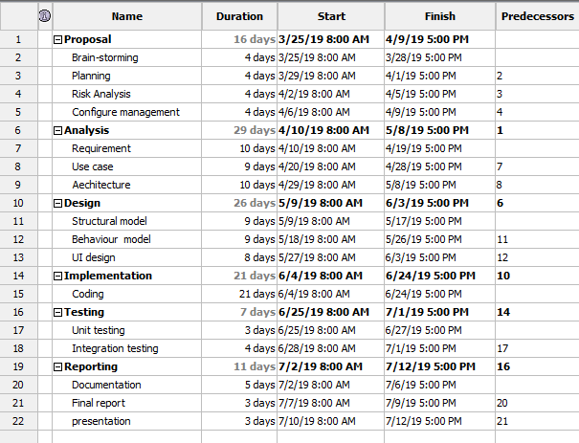

**Fig: Scheduling of project**

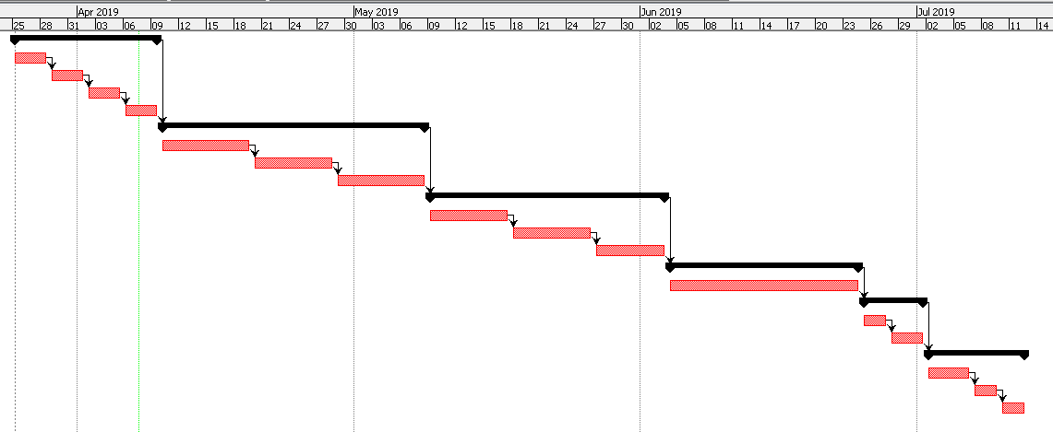

**Fig: Gantt chart**

# **Chapter 5: Risk management**

First of all, risk means an activity or event that may compromise the success of the project and can be result of losses. It can be defined as the potential problem in the simple way. It is generally caused due to lack of information, control or time. In order to enhance the probability of success of the project, all the possible risks should be identified and managed. In this way, the concept of the risk management was developed.

Risk management is the process of identifying, assessing, prioritizing the risks and taking the required actions in order to eliminate the effects of the possible identified risks. This is done in order to minimize, monitor, and control the probability of unfortunate events. The following listed process are carried out in the risk management:

* Identify the risk
* Reduce the impact of risk
* Reduce the probability or likelihood of risk
* Risk monitoring

Various type of risk and measures to be taken to prevent these risks are listed below in the table.

To calculate the impact of each identified risk we use,

**Impact = Likelihood x Consequence**

|  |  |
| --- | --- |
| **Likelihood** | **Value** |
| Low | 1 |
| Medium | 2 |
| High | 3 |

|  |  |
| --- | --- |
| **Consequence** | **Value** |
| Very low | 1 |
| Low | 2 |
| Medium | 3 |
| High | 4 |
| Very high | 5 |

|  |  |  |  |  |  |
| --- | --- | --- | --- | --- | --- |
| **S.no** | **Possible risks** | **Likelihood** | **Consequences** | **Impact** | **Actions to be taken** |
| 1 | Wrong time estimation | 2 | 2 | 4 | More focus on analysis phase as this phase defines the time required for the project and works/tasks should be carried on the planning time. |
| 2 | Insufficient resources | 2 | 3 | 6 | More focus on analysis phase as this phase is more associated with allocation of resources. |
| 3 | Sudden growth of requirements | 3 | 3 | 9 | More focus on requirement analysis |
| 4 | Hard drive failure | 2 | 3 | 6 | Back-up files for the future reference or save it to the cloud as back-up. |
| 5 | Natural calamities | 1 | 4 | 4 | Back-up files for the future reference or save it to the cloud as back-up. |
| 6 | Government rules changes | 1 | 4 | 4 | Changes must be done according to the law with less affect. |
| 7 | Errors while coding | 3 | 2 | 6 | Focus while coding and practice more as it will develop the coding skills. |
| 8 | Conflicting priorities | 2 | 4 | 8 | Do more analysis on user requirement and give rank to the priorities. |
| 9 | Ineffective design | 2 | 4 | 8 | Focus on user requirements and design phase. |

# **Chapter 6: Configuration management**

First of all, configuration is the set of characteristics that define a final product or deliverable. This includes all functional and physical specifications. configuration management is managing the configuration of all of the project’s key products and assets. This includes any end products that will be delivered to the customer, as well as all management products.

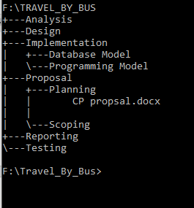

**Fig: Configuration management of the project**

# **Chapter 7: Conclusion**

# **References**

Anon., n.d. *Hygger.* [Online]   
Available at: <https://hygger.io/blog/milestones-project-management-define/>  
[Accessed 6 4 2019].